1. **$find:** This will search for a file in a directory hierarchy.
2. **$mkdir subdir:**This will create a subdirectory
3. **$touch today.txt:** This will create a file.
4. **$find . –type d:** displays only directory.
5. **$find . -type f:** displays the filename
6. **Sfind . -type f –iname demo.txt**:This ‘i’ is used to ignore case sensitivity.

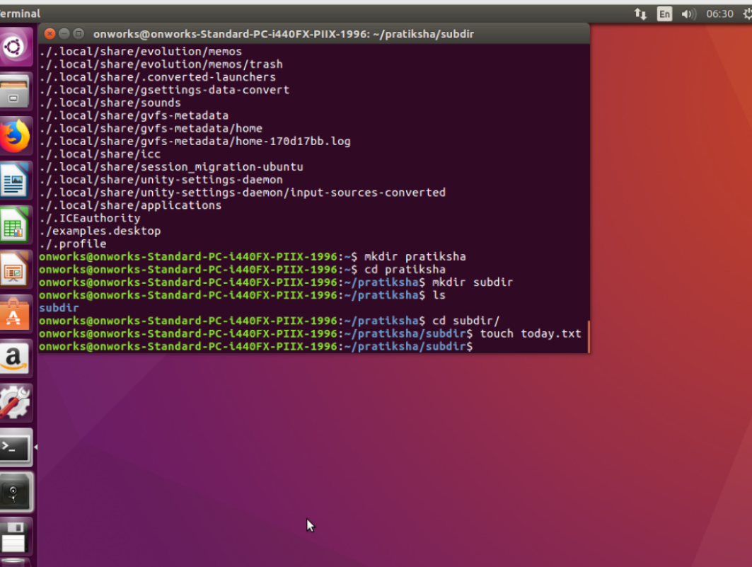

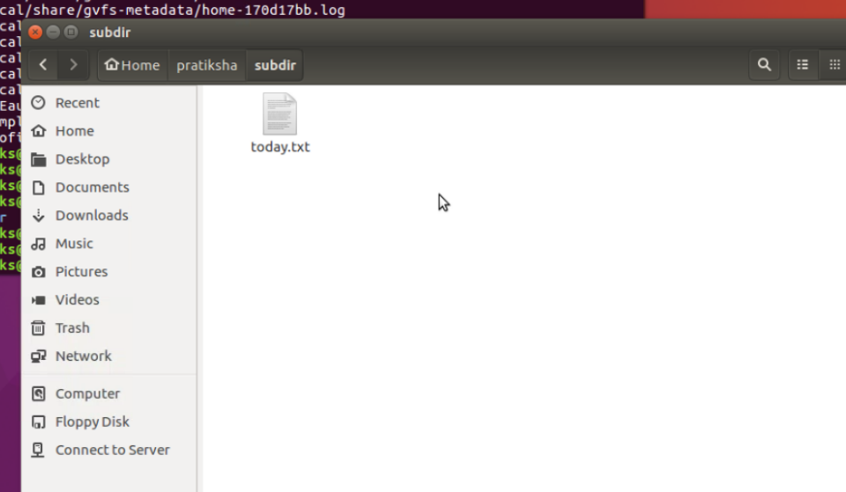

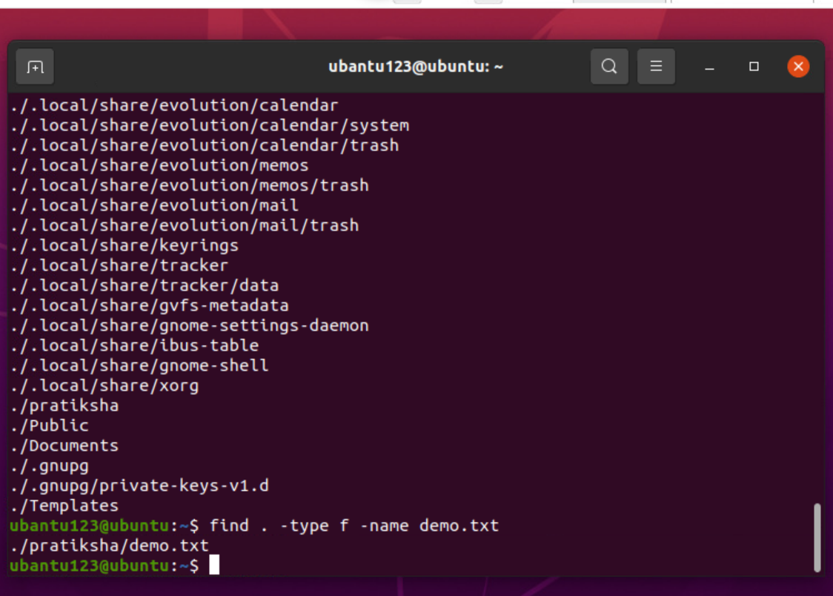

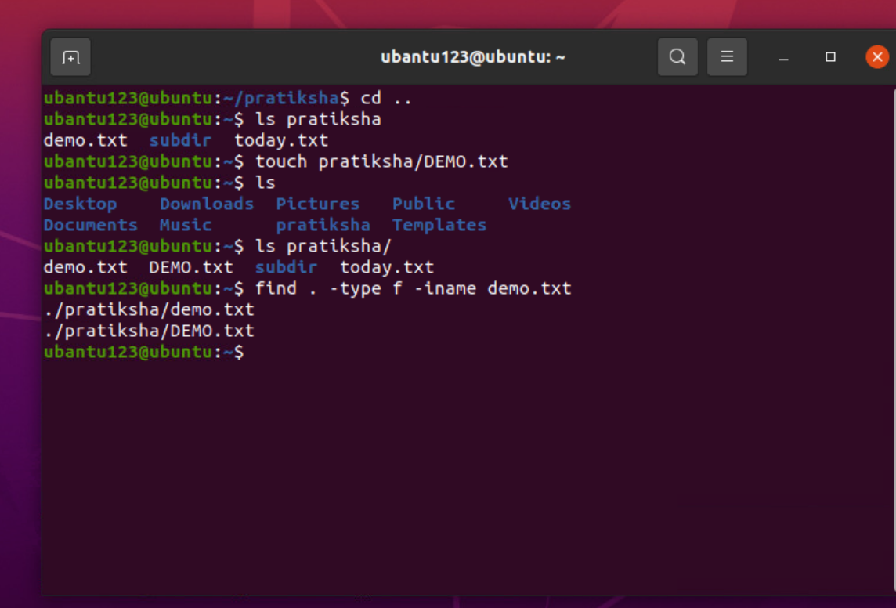

1. **$find . -type f –perm 0664:** This will give find the file which has the permission read write for group and user and only read for others.

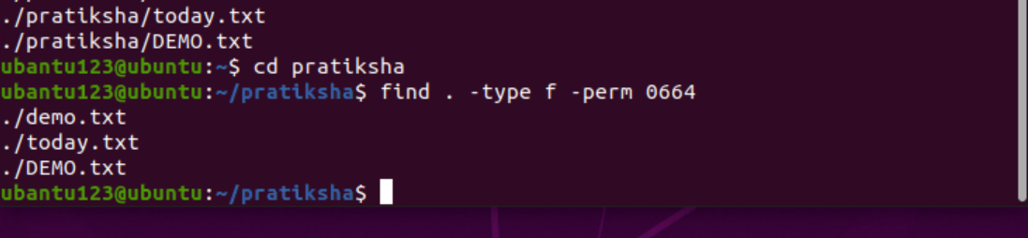

1. **$find . -mtime –1:** This will show the file which is opened within 24 hours of time.

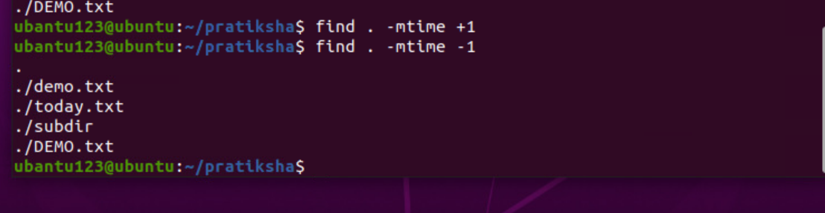

1. **$find . mmin +1 –mmin -3:** Gives the file more that has been used more than 1 min less than 3 min.
2. **$find . -Size –1M:** Displays the file which is less than 1 mb.

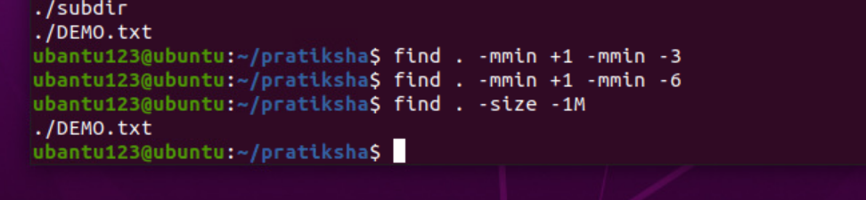

1. **$find . / -empty:** This will displays the empty files.

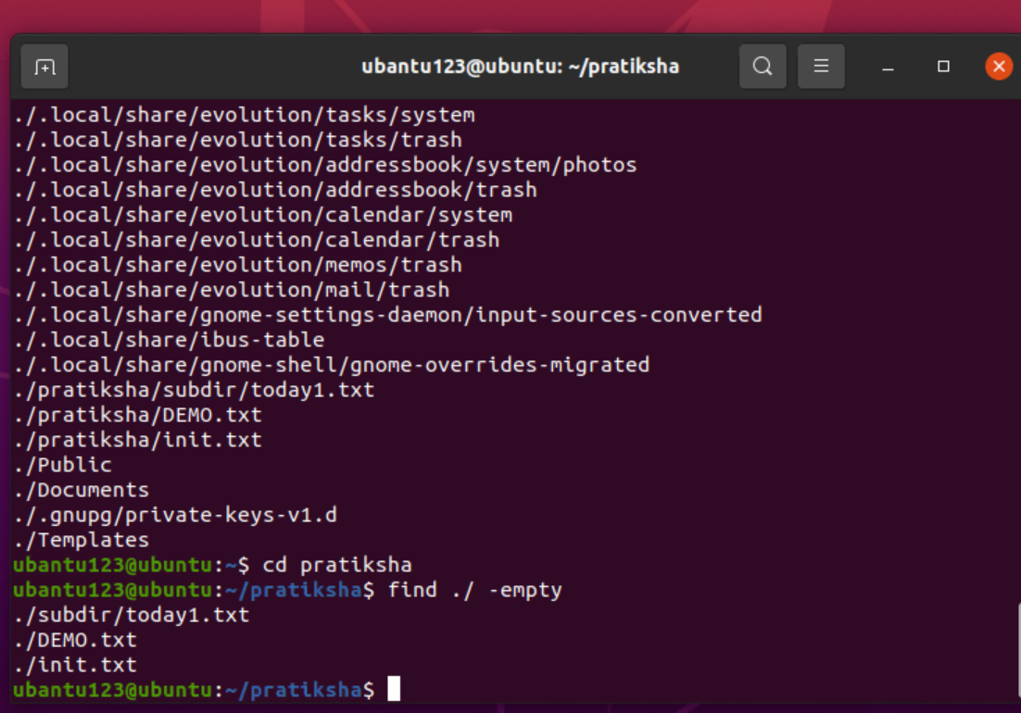

1. **$find . -type f –name “*.txt” --exec grep ‘in’ {} \;** :This will open the .txt file and search for the ‘in’ word in the content of the file.

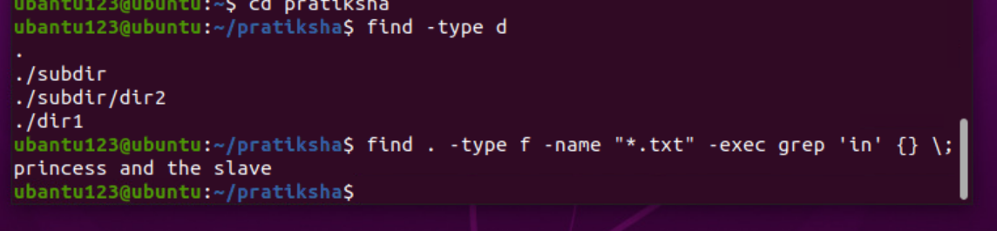

1. **$find > -type f –name “d*”:** This will display file that containing the filename starting with the ‘d’.

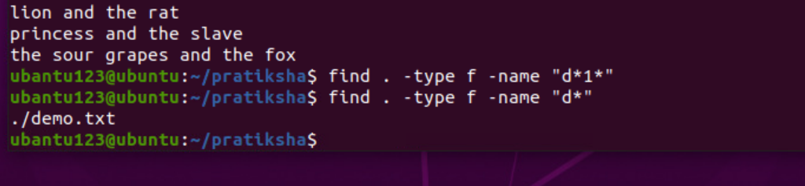

**INTRODUCTION TO BASH SHELL**

**TERMINAL:** Program to interact with shell.

**SHELL:** Command line, It is a layer between the operating system kernel and the user.

**BASH:** Unique shell and command launguage interpreter.

The first line should always begins with “ **#!/usr/bin/bash “**

**I/O REDIRECTION:**

* >: Redirects the standard output.
* <: Accept input from a file
* >>: creates a file if not present, otherwise appends to it.
* <<: Forces the input to a commands to be the shell input.

**ADDITION OF TWO NUMBERS:**

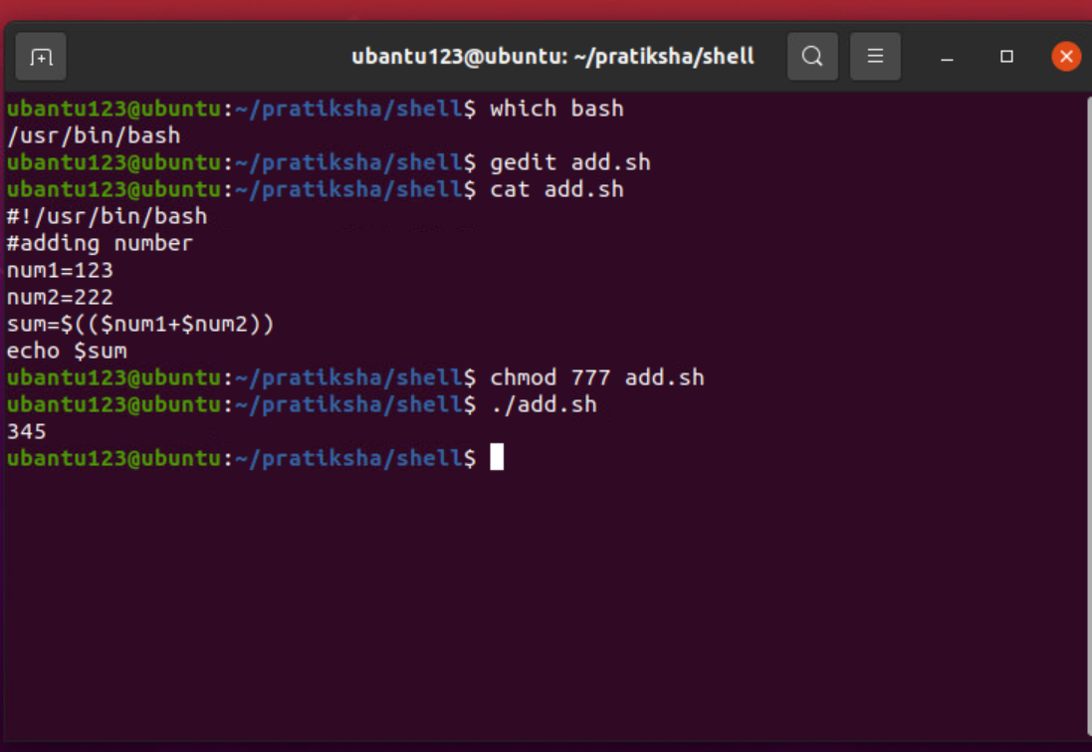

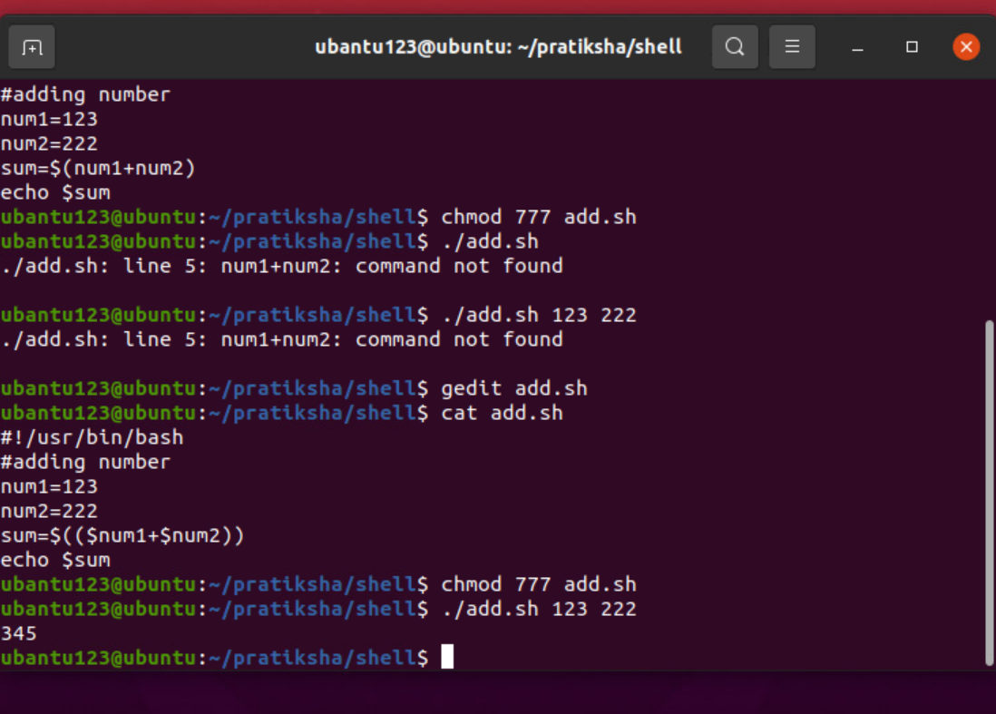

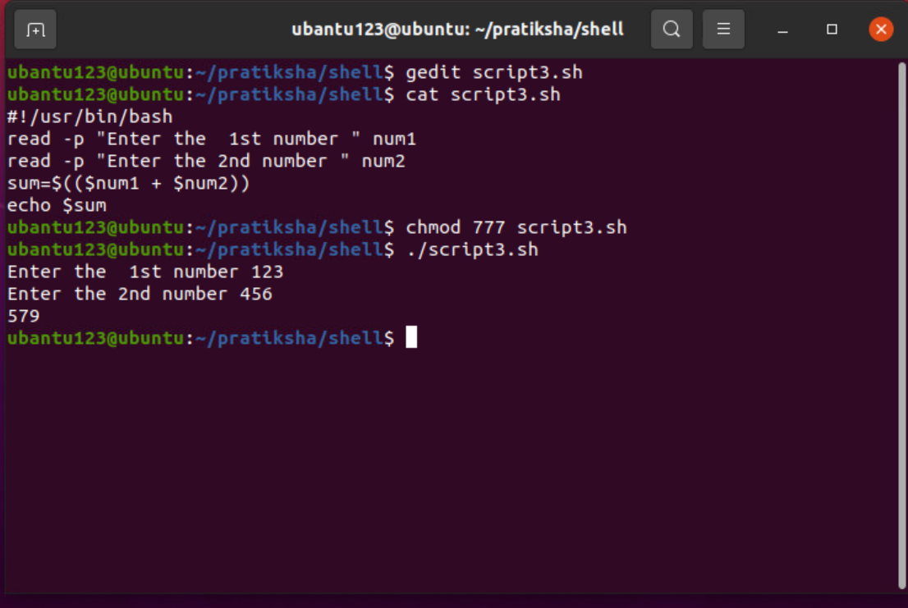

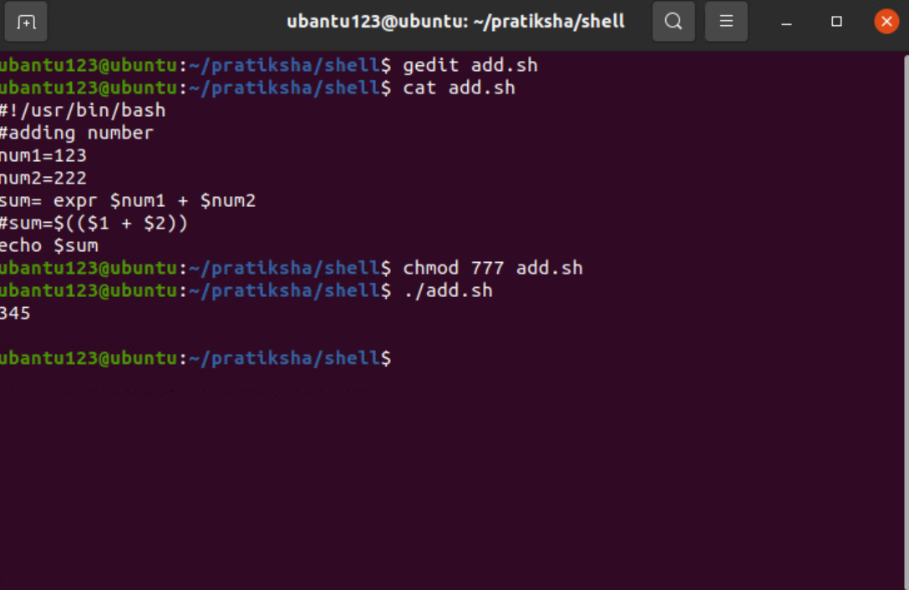

**CONCATING THE STRING**

